18.16: (a) The force of any side of the cube is 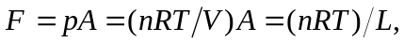 since the ratio of area to volume is

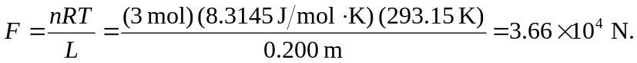

b) For 